**Antique Sunburst & Stars Mirror**

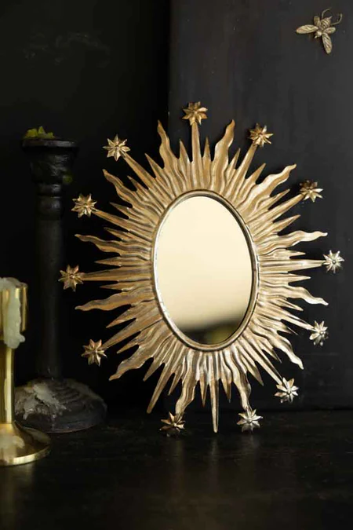The Antique Sunburst & Stars Mirror is a captivating piece that embodies both celestial beauty and vintage elegance. Its intricate design features a radiant sunburst pattern, with delicate star accents radiating from the center. This unique combination creates a dazzling effect that enhances the mirror's reflective surface, adding a touch of glamour and sophistication to any room. The antique finish further elevates its charm, offering a timeless appeal that complements both traditional and contemporary interiors. Perfect for those looking to make a statement, this mirror serves as both a functional accessory and an eye-catching focal point in any space.